**C# Basics Tutorials**

**Exception Handling:**

**2. Inner Exception:**

* + The “InnerException” property returns the Exception instance that caused the current exception.
  + To retain the original exception pass it as a parameter to the constructor of, the current exception.
  + Always check if the inner exception is not null before accessing any property of the inner exception object, else you may get Null Reference Exception.
  + To get the type of the InnerException use GetType() method.

**3. Custom Exception**:

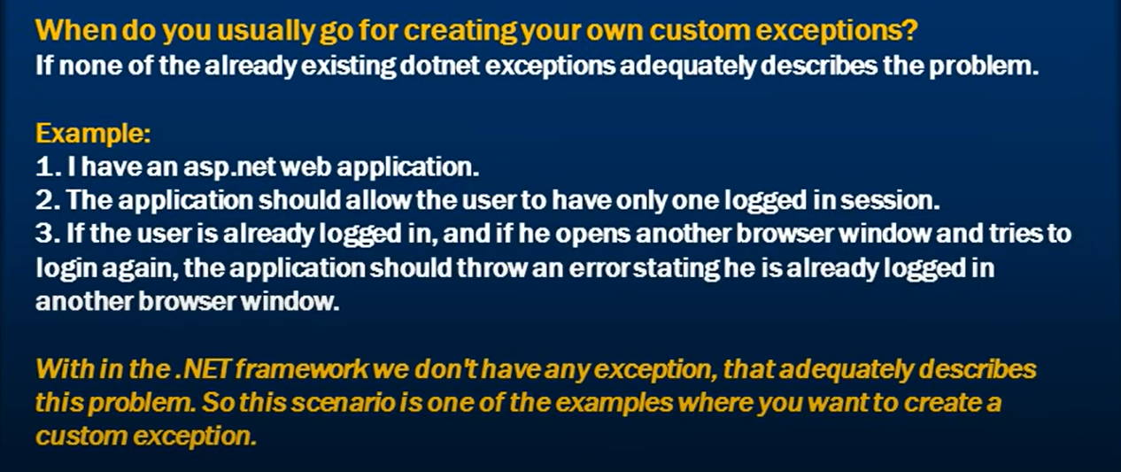

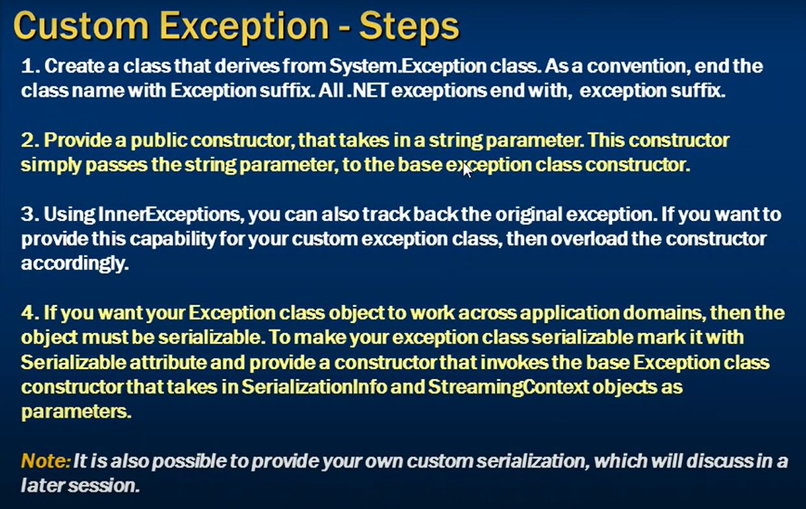

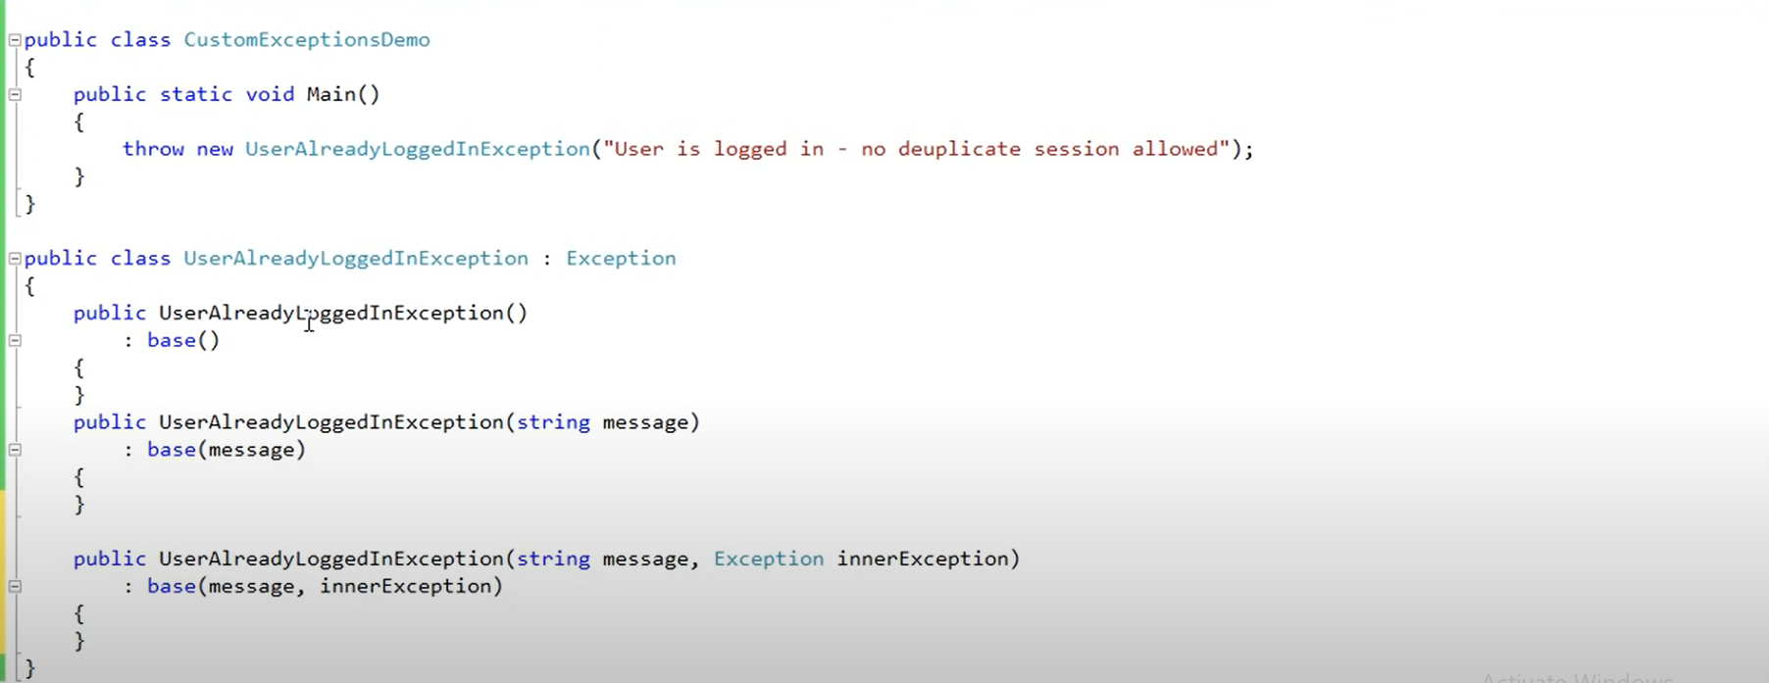

In the above snippet of code, we created a custom Exception, which only accessible/working in the current context/namespace. If we want to make it remote able/serialize, then we have to add Serializable identifier above the class as added in below code snippet and also create a constructor for serialization info. This is useful when we two applications, and wats to talk to each other, then we have to transfer the obj of one to the other over the network.

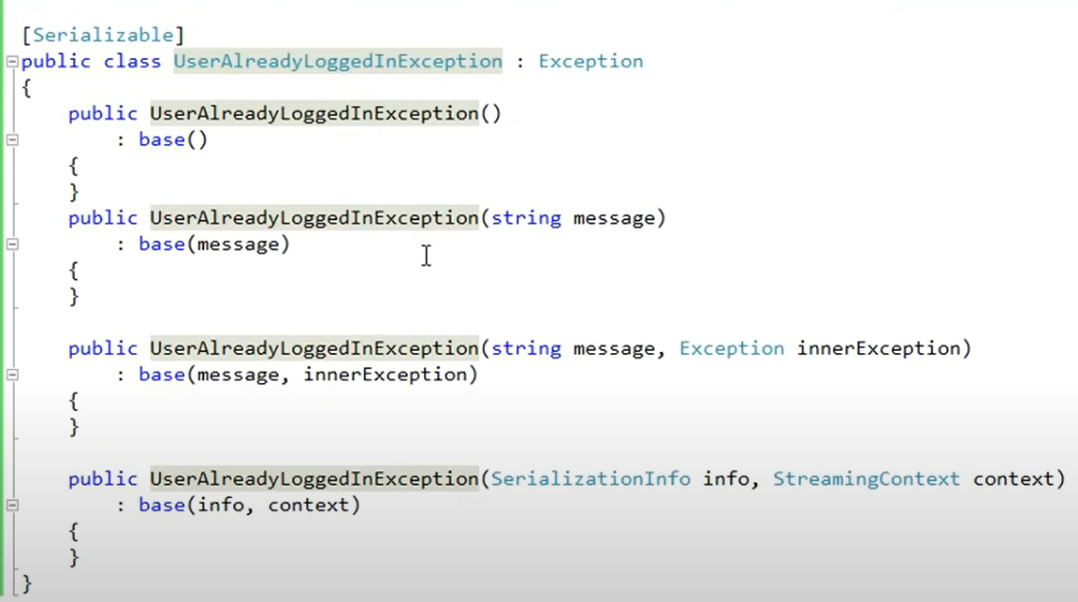

**Exception Handling Abuse:**

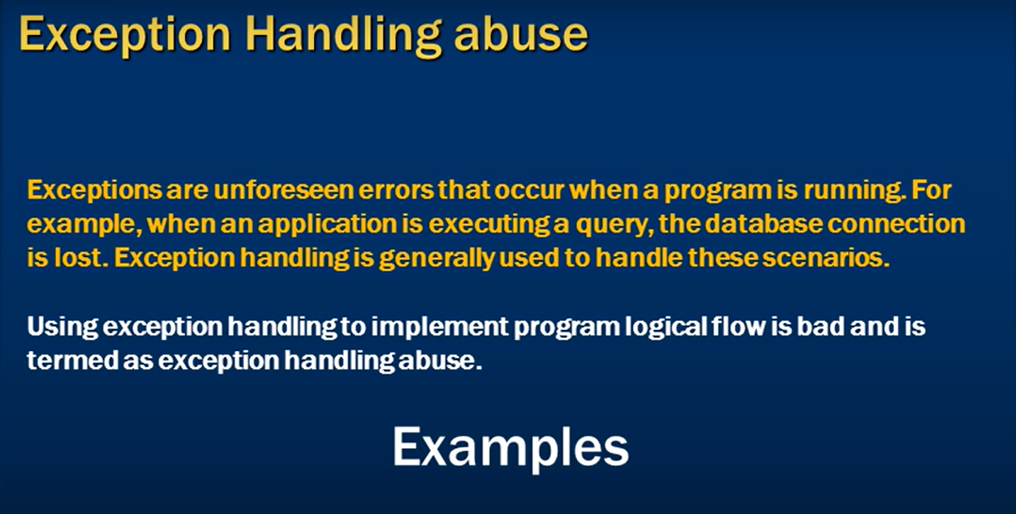

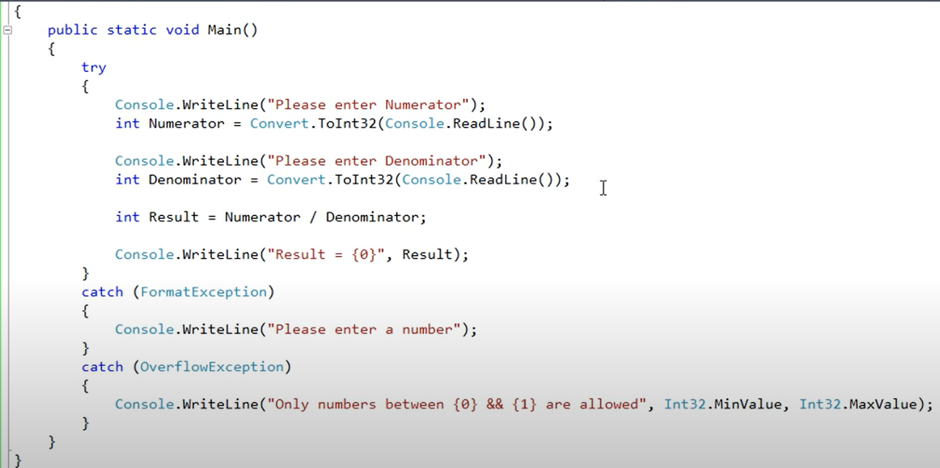



In the above code snippets, we use Exceptions to handle three types of scenarios

1. If user input a string instead of number
2. If input number is too big to store in “Int32”
3. If user input denominator as zero

The way we handled these cases is wrong. It is called Exception handling abuse. Instead of using exception we can handle these scenarios by “if else” in the program logic.

**Preventing Exception Handling Abuse:**

As we discussed above that the way to prevent this by using “If else” in program logic.

It is done and shown below.

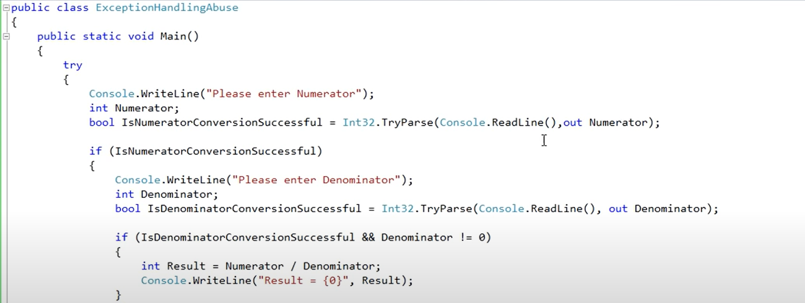

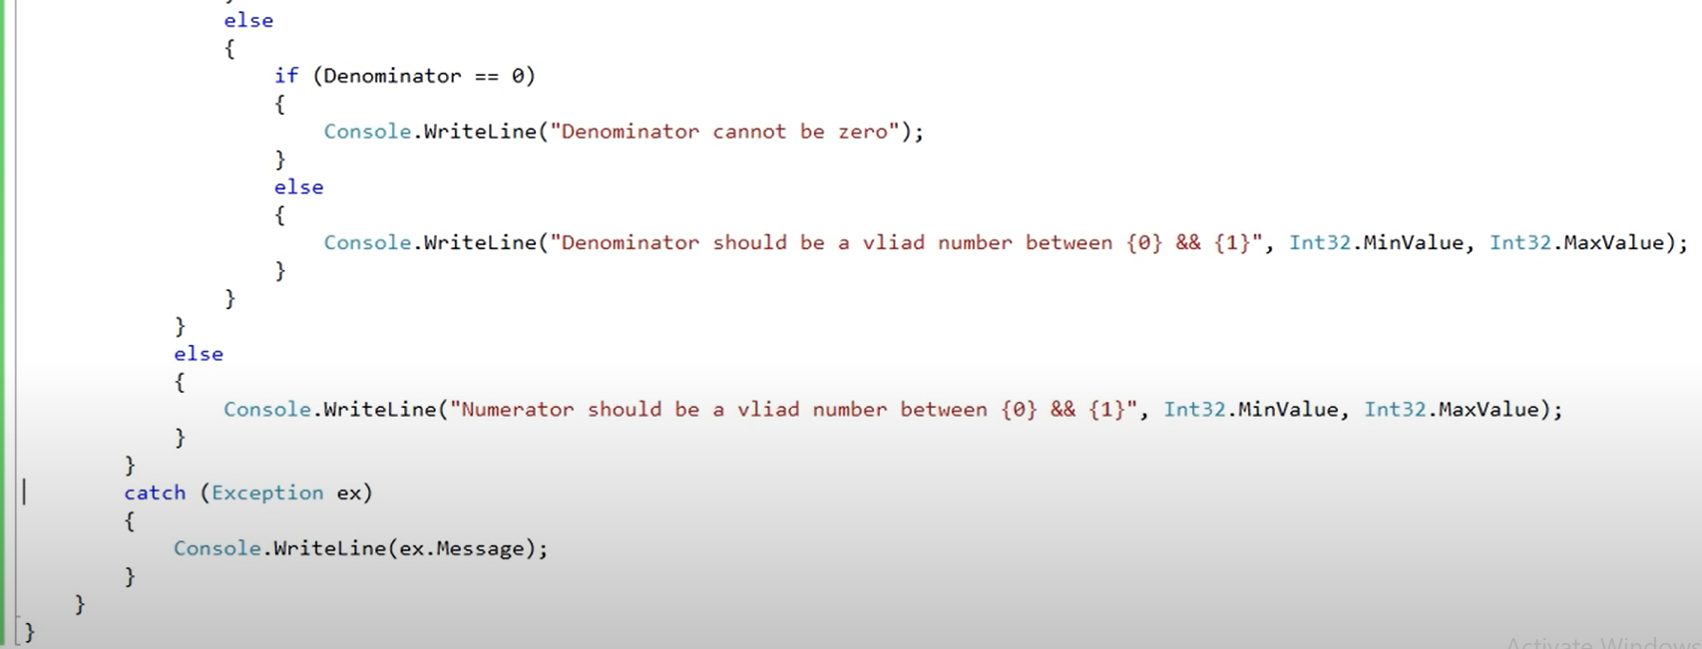

**Why Enums:**

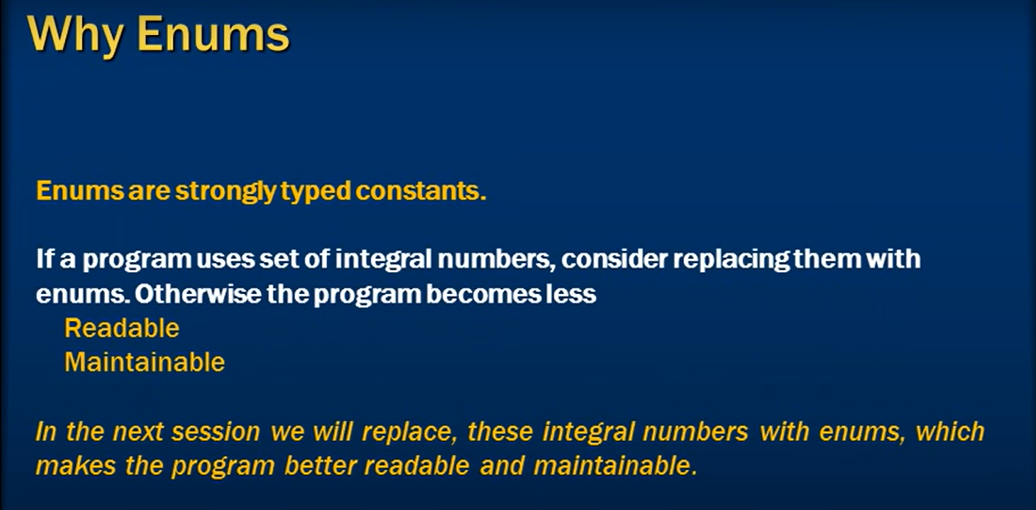

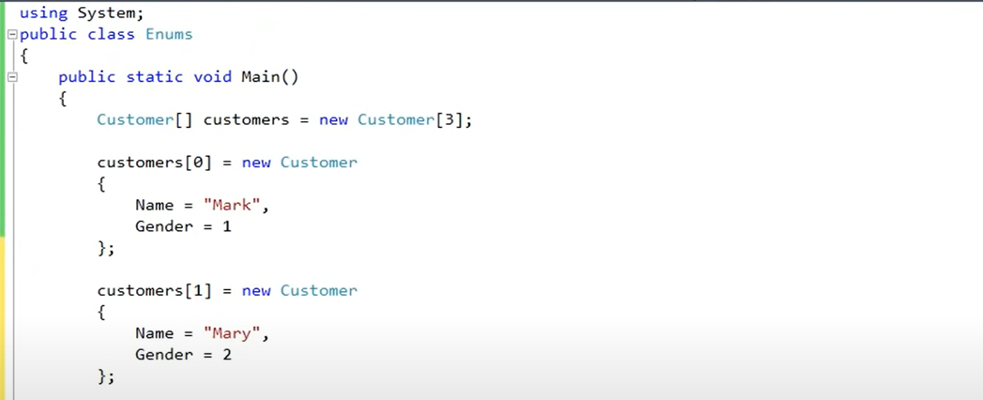

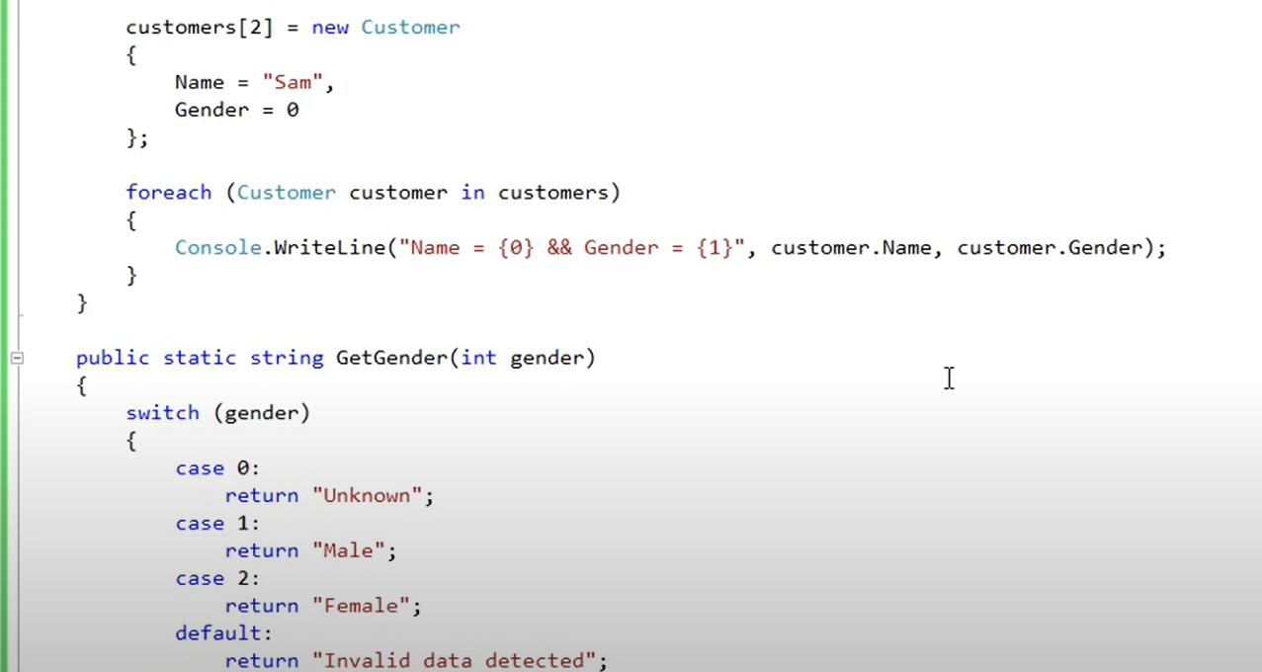



As we can see in the above code snippets, that to mention a new customer gender we have to look into some document of DB or summary that which number is related to which gender. The other thing is that if we want to print the customers gender then we have to define a method which translates the numbers into related genders.

Think of scenario where we have such a large number and their associated values then there will difficult to remember for all numbers. So here comes Enums.

**Using Enums:**



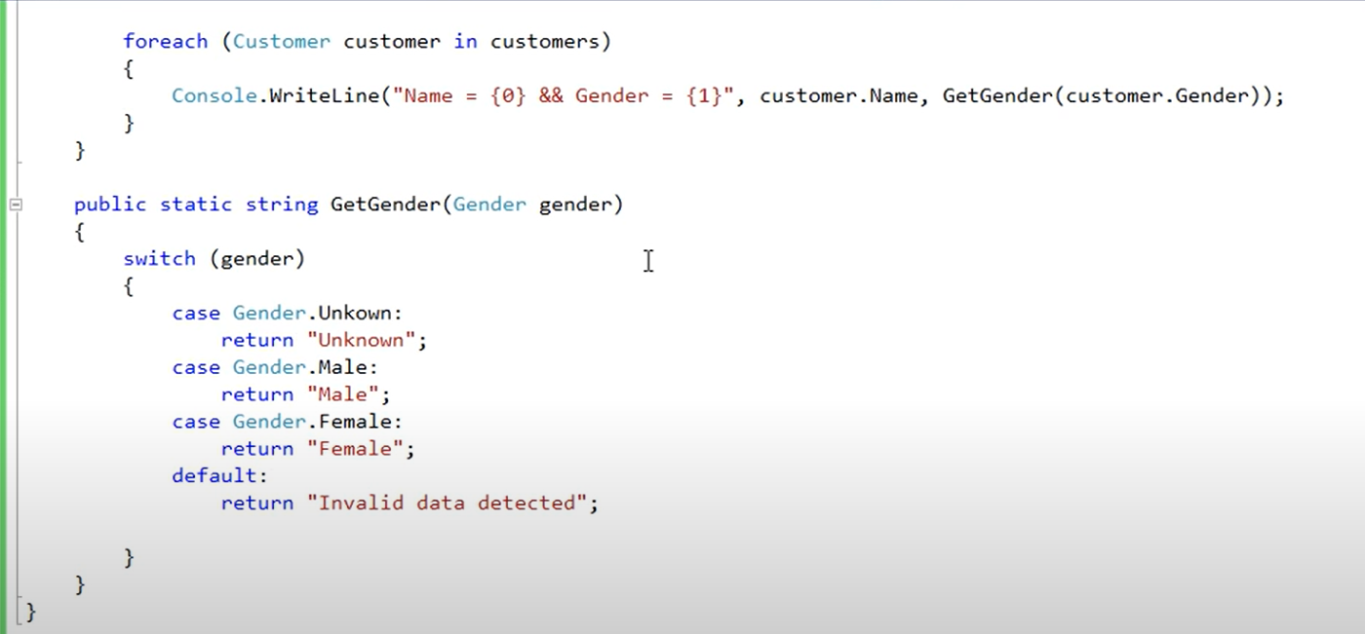

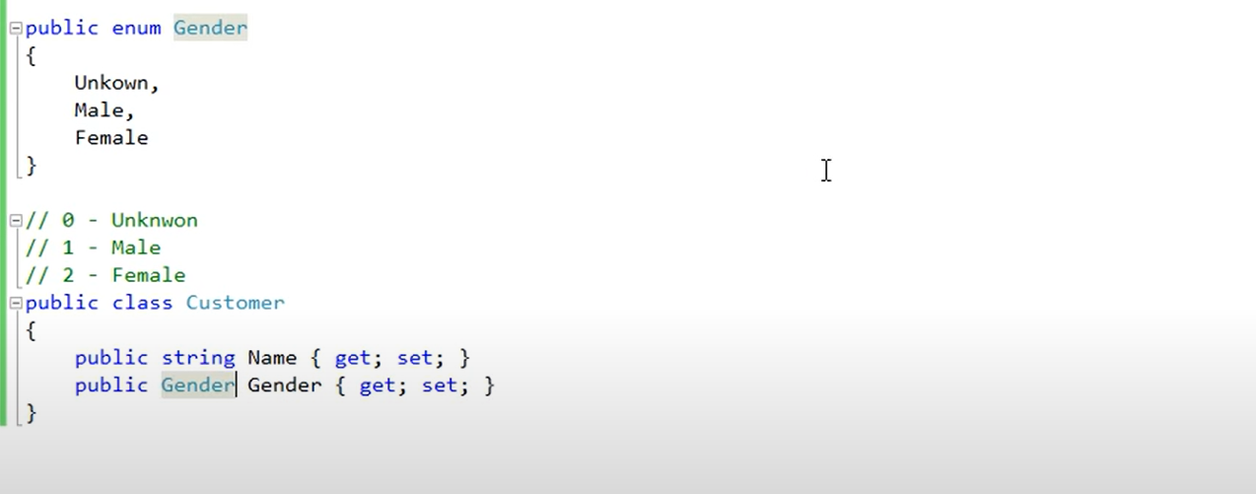

As you can see the changes in the code using Enums. Now the program is more readable and maintainable.

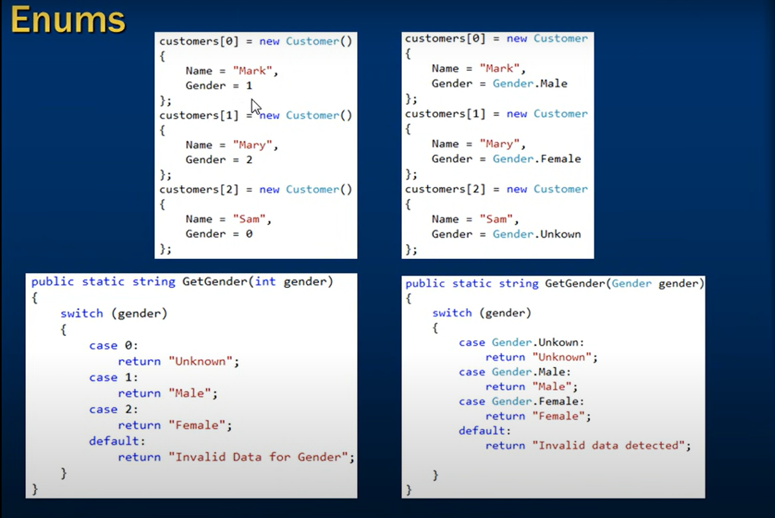

**Enums:**

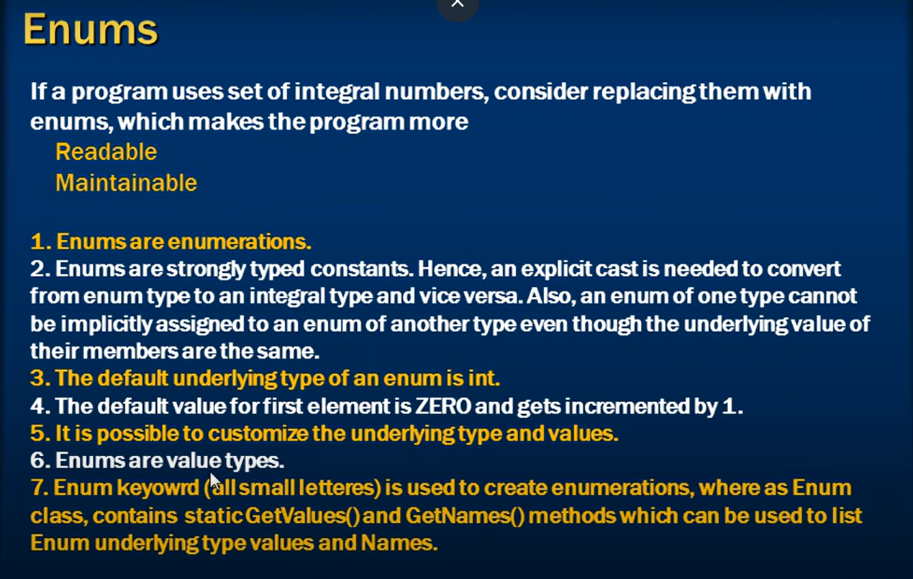

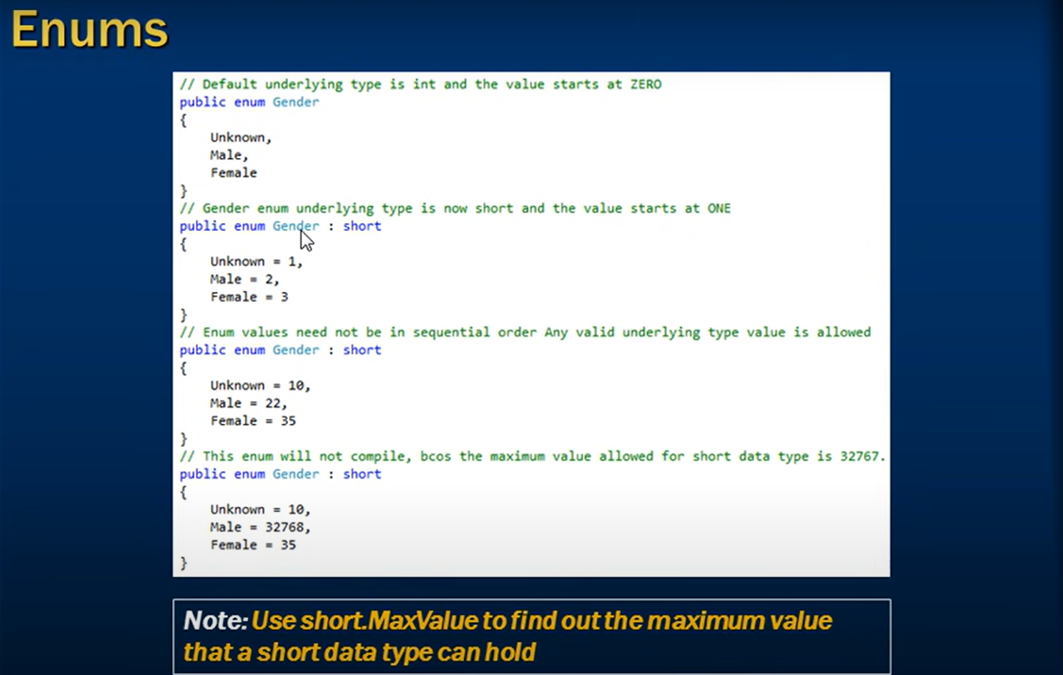

**Type Vs Type Members:**

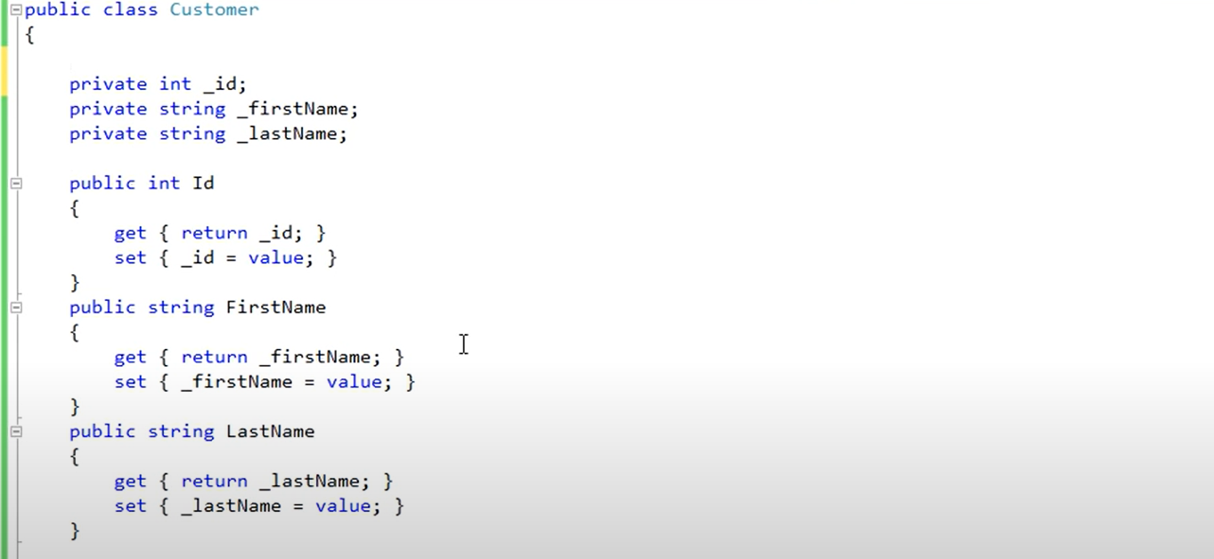



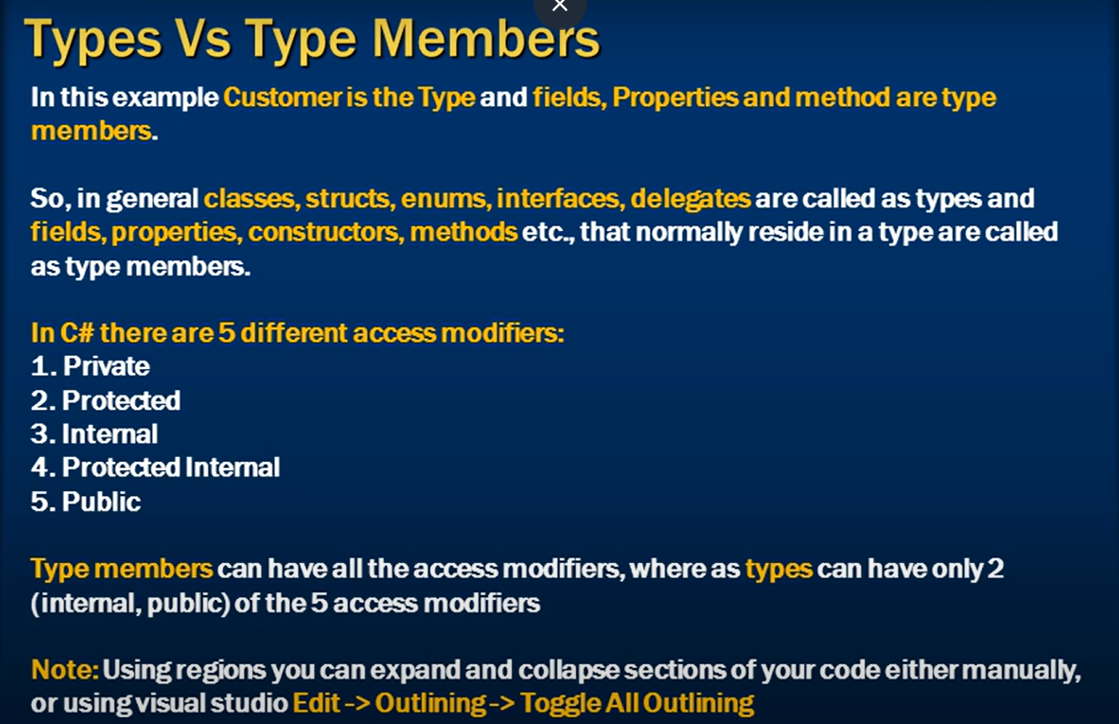

**Generics:**

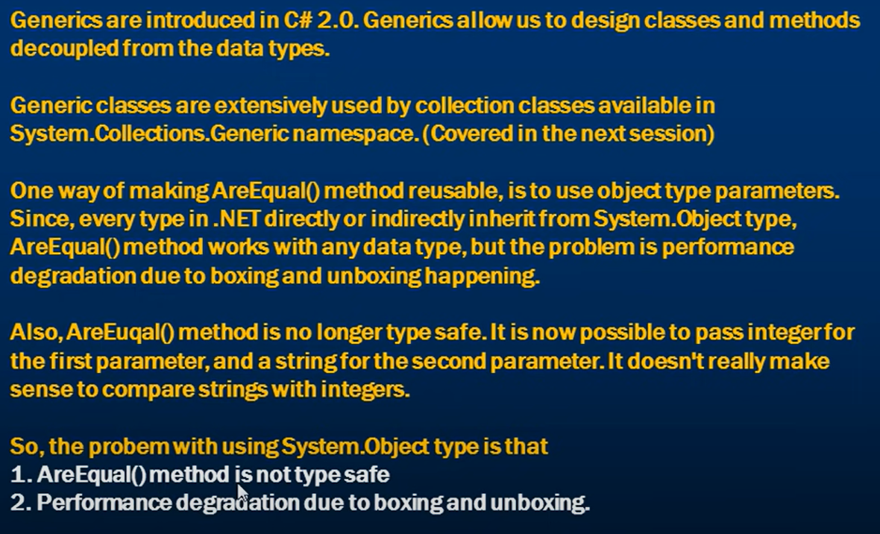

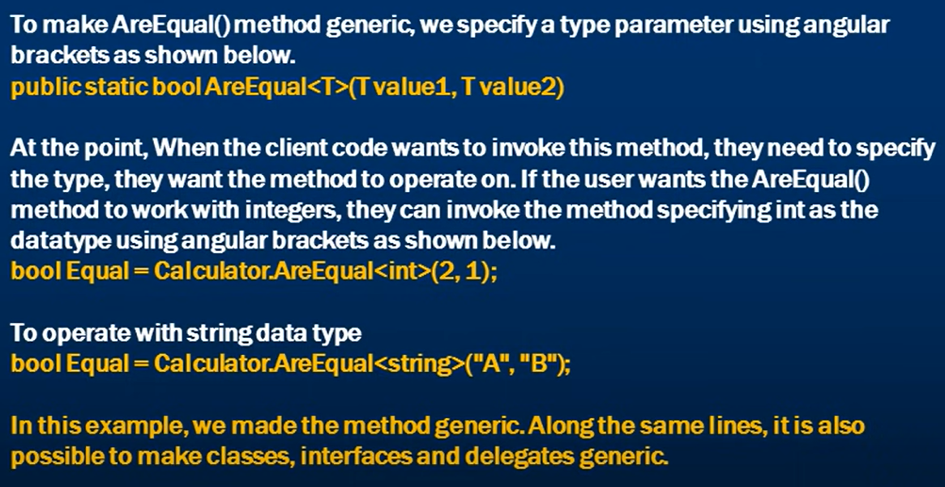

**Dictionary in C#:**

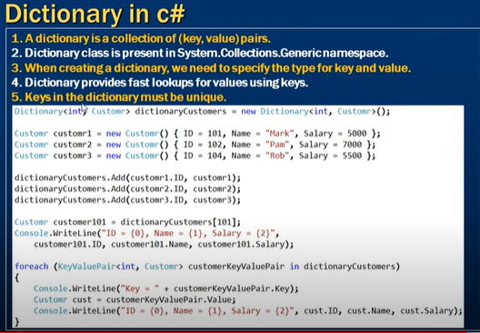

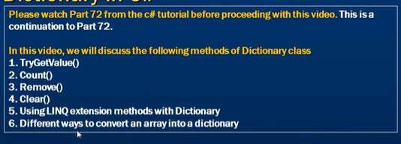

**Multi-Threading**

* **Dead-Locks**

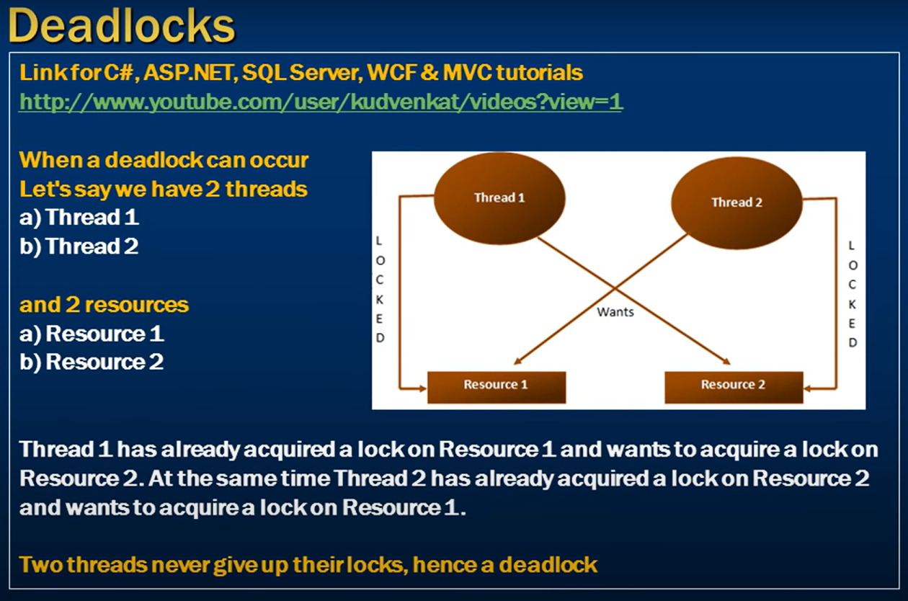

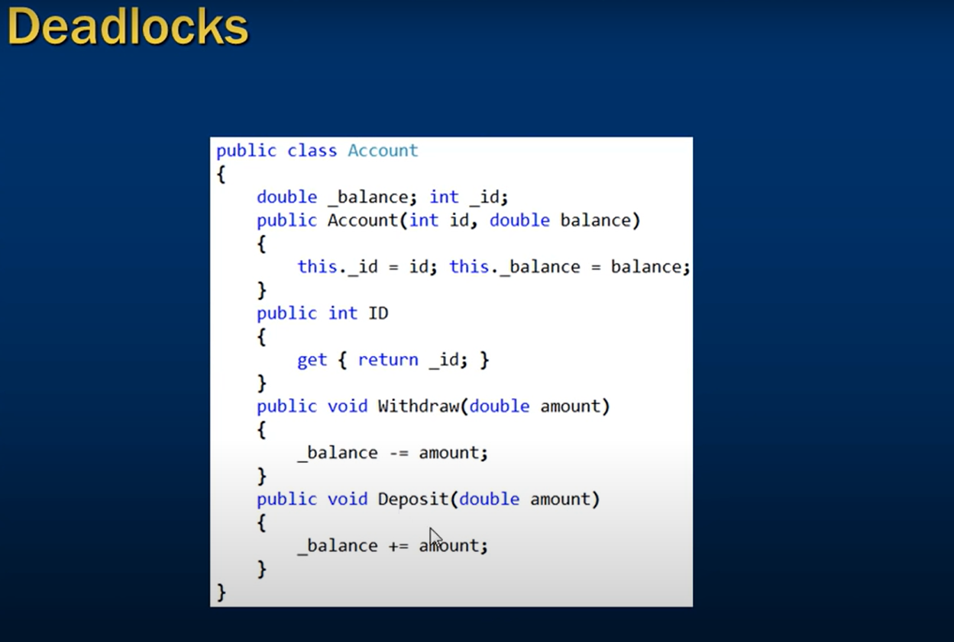

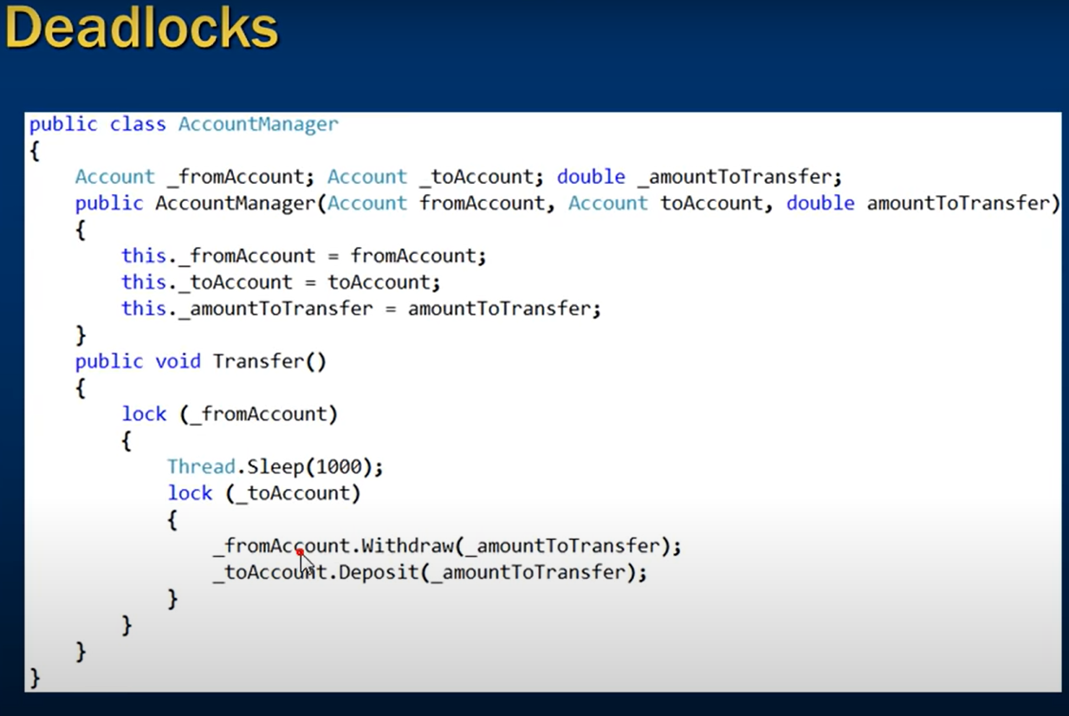

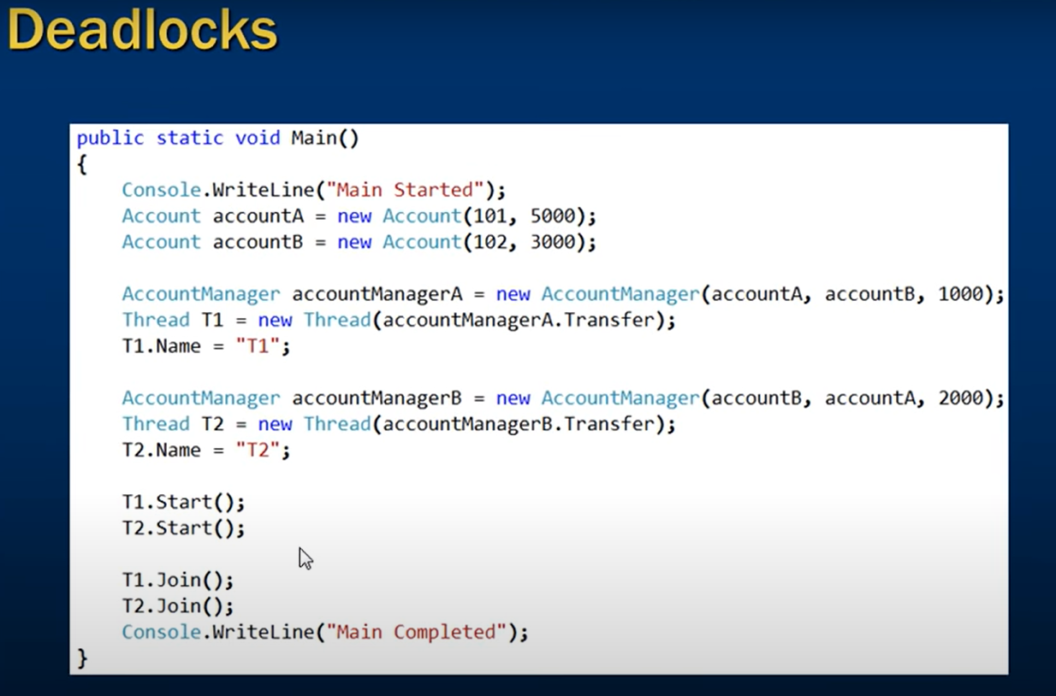

**Resolving Dead-locks**



**1.Acquiring locks in a specific defined order**

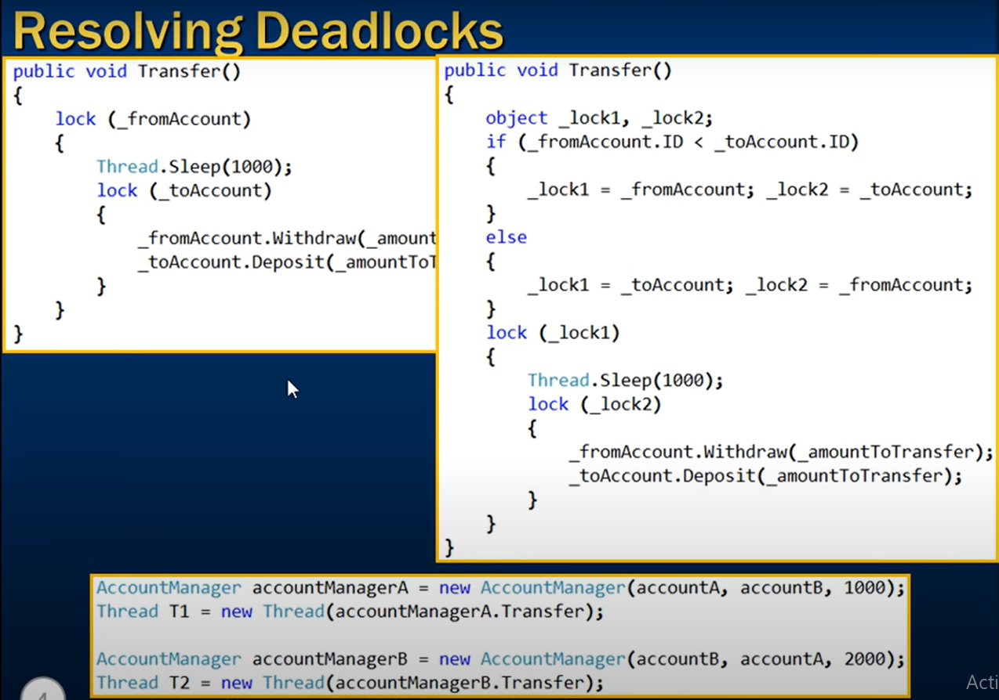

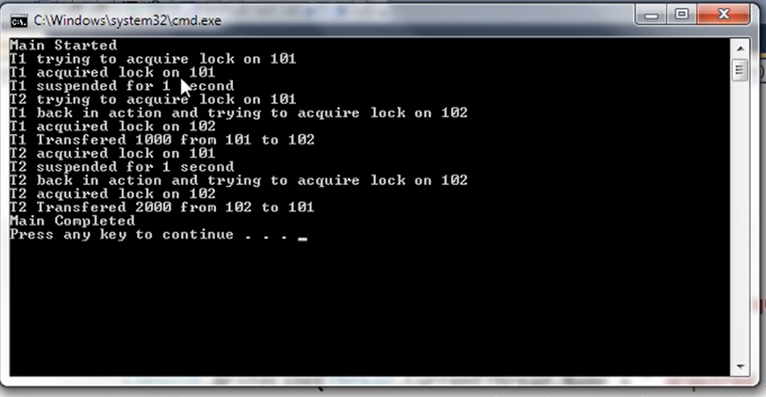

**Performance Implications**

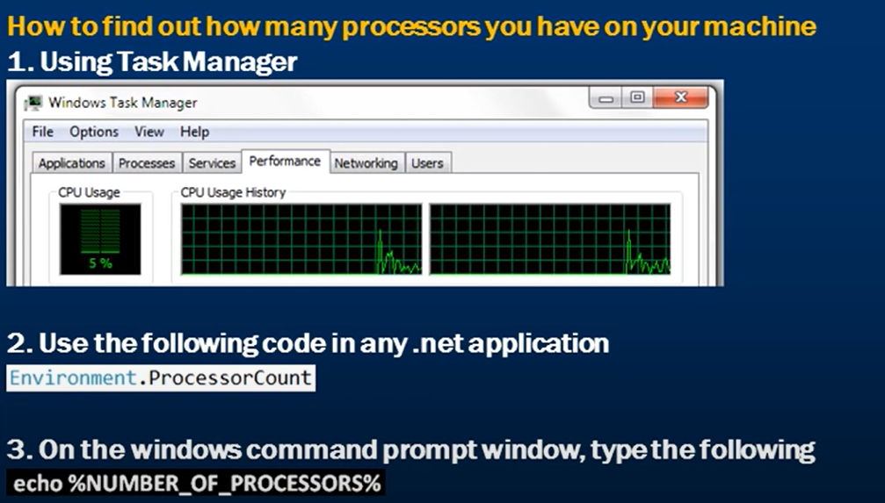

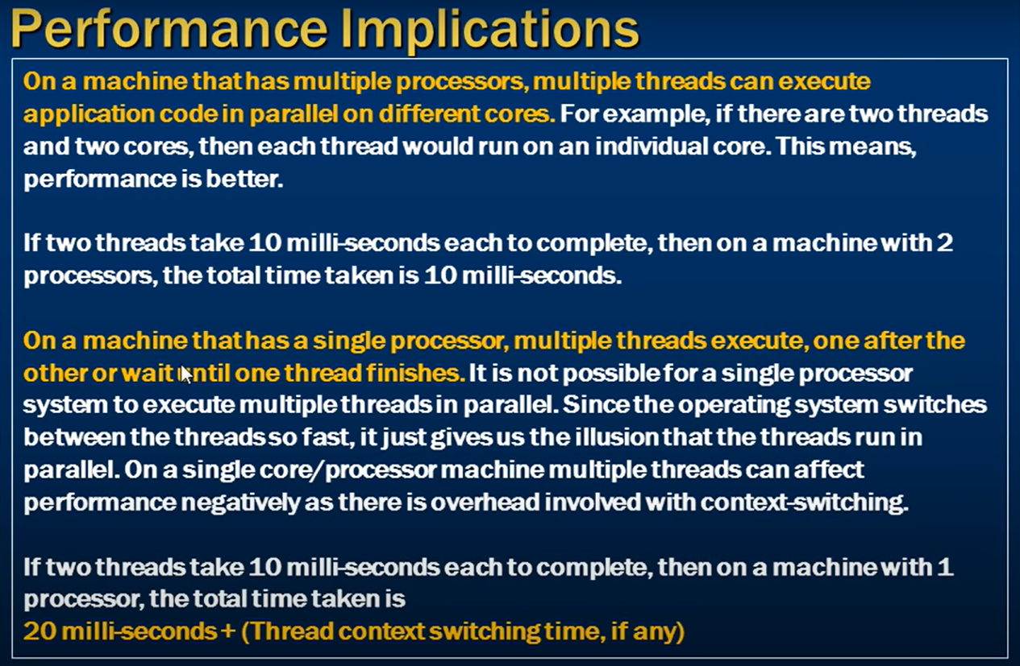

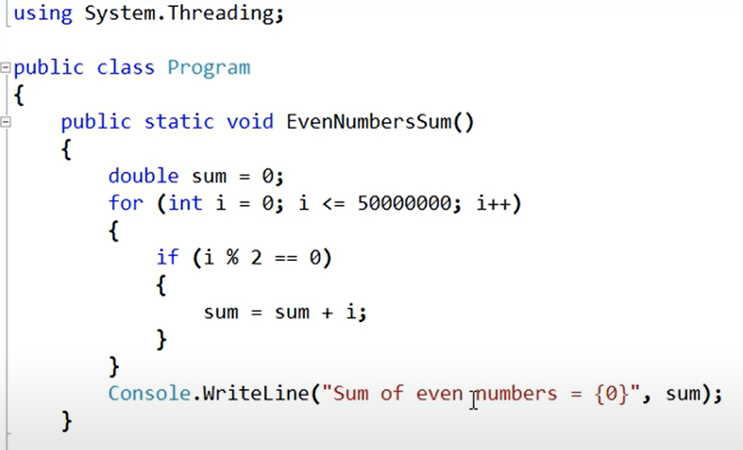

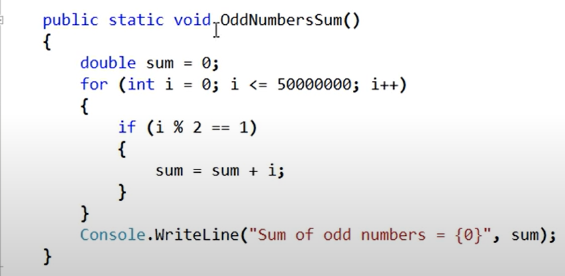

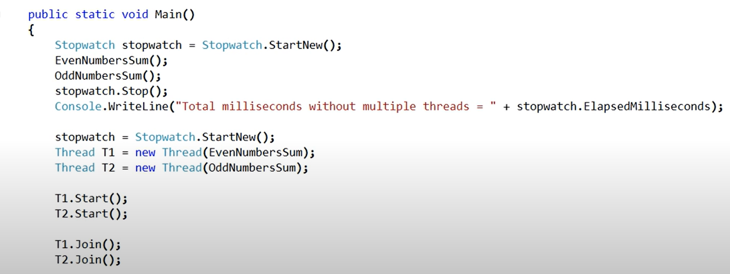

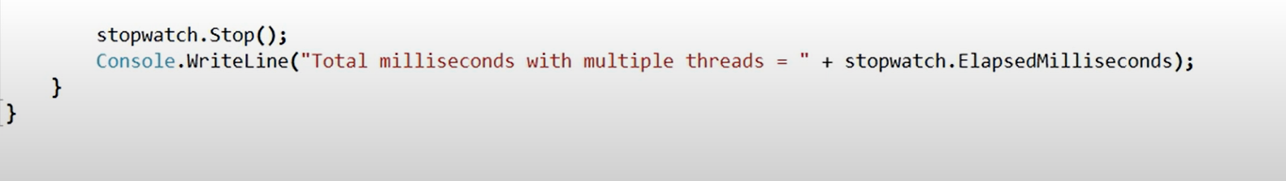

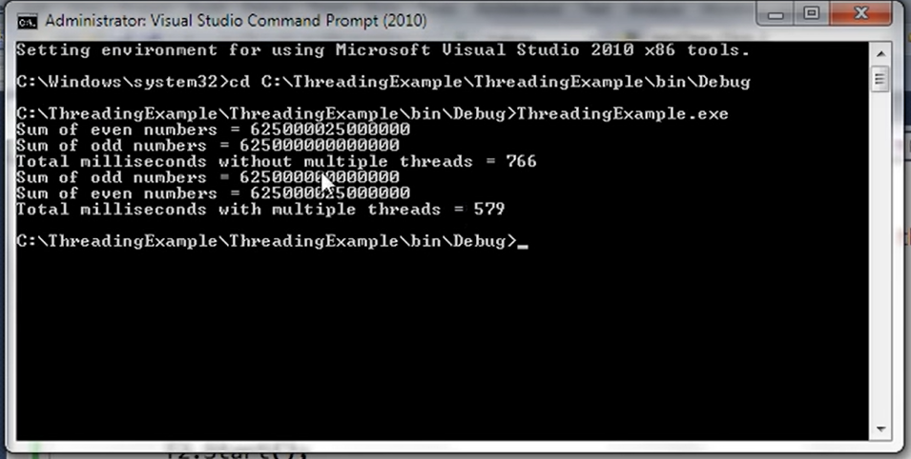

**Anonymous Methods**

